AI ASSISTED CODING LAB EXAM 4
HTNO:2503A52L17

Q1. (Database & SQL)
- Design tables for a Smart Farming IoT sensor network.
- Write queries to detect sensors with abnormal readings. Q2. (Data Processing)
- Clean inconsistent timestamps in IoT logs using AI.
- Resample data for hourly aggregation

  - FORM TABLE:

CODE:
CREATE TABLE FARM (
farm_id INT AUTO_INCREMENT PRIMARY KEY,
farm_name VARCHAR(100) NOT NULL, location VARCHAR(255),
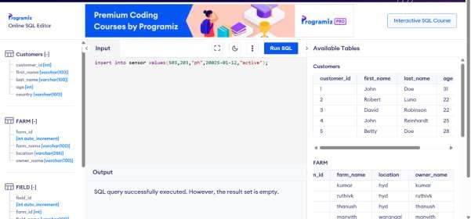
owner_name VARCHAR(100));

FIELD TABLE:
CODE:

CREATE TABLE FIELD (
field_id INT AUTO_INCREMENT PRIMARY KEY,
farm_id INT,
field_name VARCHAR(100) NOT NULL, crop_type VARCHAR(100),
FOREIGN KEY (farm_id) REFERENCES FARM(farm_id));
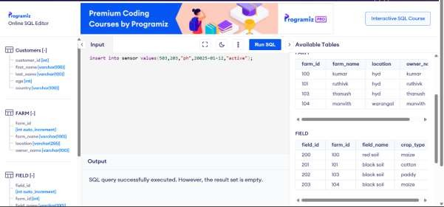
CENSOR TABLE:
CODE:
CREATE TABLE SENSOR (
sensor_id INT AUTO_INCREMENT PRIMARY KEY,
field_id INT,
sensor_type VARCHAR(50) NOT NULL, -- e.g., Temperature, Soil Moisture install_date DATE,
status VARCHAR(20) DEFAULT 'Active',
FOREIGN KEY (field_id) REFERENCES FIELD(field_id)
);

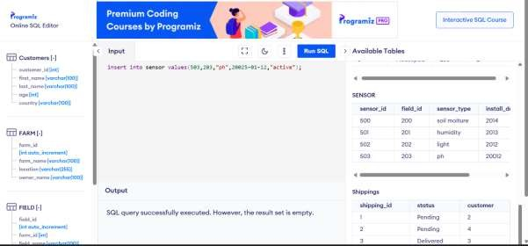

Q2. (Data Processing)
- Clean inconsistent timestamps in IoT logs using AI.
- Resample data for hourly aggregation

BEFORE CLEANING CODE:
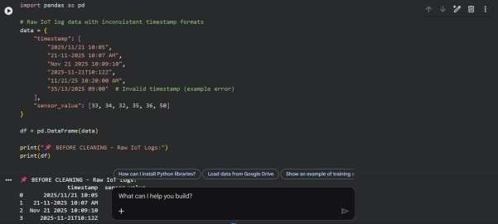

AFTER CLEANING CODE:

